AWS EC2

Amazon Elastic Computing Cloud- AWS EC2

Case Study

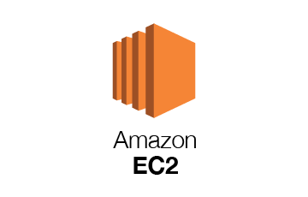

**Amazon EC2**

**How to Create EC2 Instance in AWS: Step by Step Tutorial**

**Step 1) Login and access to AWS services**

* 1. Sign in to the Console
  2. If you don’t have an account please create it. Then log in
  3. Login to your AWS account and go to the AWS Services tab at the top left corner.
  4. Here, you will see all of the AWS Services categorized as per their area viz. Compute, Storage, Database, etc. For creating an EC2 instance, we have to choose Computeà EC2 as in the next step.

* Open all the services and click on EC2 under Compute services. This will launch the dashboard of EC2. Here is the EC2 dashboard. Here you will get all the information in gist about the AWS EC2 resources running.

Step 2)

On the top right corner of the EC2 dashboard, choose the AWS Region in which you want to provision the EC2 server. Here we are selecting Asia Pacific (Mumbai)-ap-south-1. AWS provides 10 Regions all over the globe.

Step 3)

* Once your desired Region is selected, come back to the EC2 Dashboard.
* Click on ‘Launch Instance’ button in the section of Create Instance (as shown below).
* Instance creation wizard page will open as soon as you click ‘Launch Instance’.

Name The Instance or Tag it

Step 4) Choose AMI

You will be asked to choose an AMI of your choice. (An AMI is an Amazon Machine Image. It is a template basically of an Operating System platform which you can use as a base to create your instance).

Once you launch an EC2 instance from your preferred AMI, the instance will automatically be booted with the desired OS. (We will see more about AMIs in the coming part of the tutorial).

Here we are choosing the default Amazon Linux (64 bit) AMI.

Step 5) Choose EC2 Instance Type

In the next step, you have to choose the type of instance you require based on your business needs.

We will choose t2.micro instance type, which is a 1vCPU and 1GB memory server offered by AWS.

Click on “Configure Instance Details” for further configurations.

* In the next step of the wizard, enter details like no. of instances you want to launch at a time.
* Here we are launching one instance.

**Step 6) Choose Numbers of Instances**

No. of instances- you can provision up to 20 instances at a time. Here we are launching one instance.

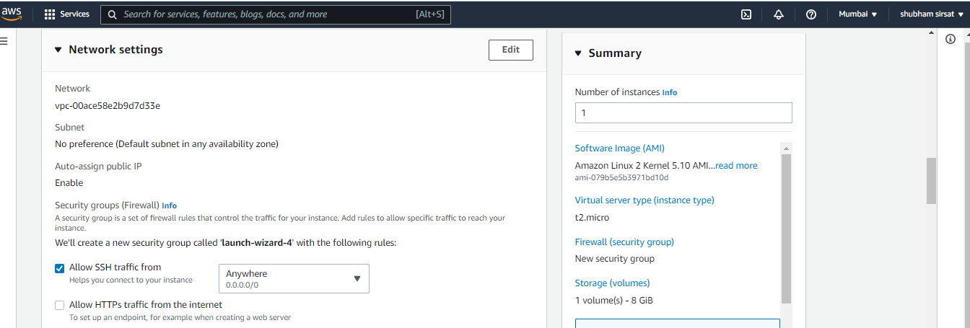

**Step 7) Key pair (login)**

You can use a key pair to securely connect to your instance. Ensure that you have access to the selected key pair before you launch the instance.

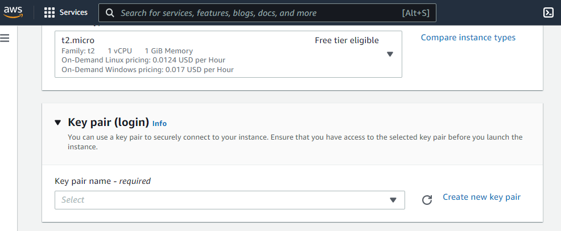

Or you can create new key pair

Give name to key

Select which file format you want to download it .pem or .ppk file

Click on create key pair and your file is downloaded in download folder please check it , the file

* When you download your key, you can open and have a look at your RSA private key.

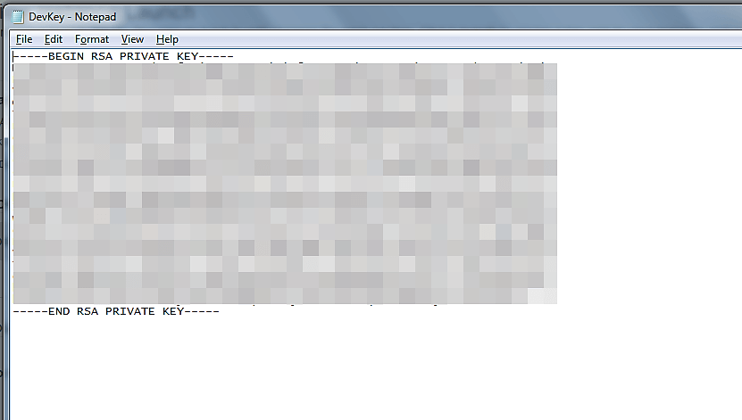

**Step 8) Network Settings**

* Next, we have to configure some basic networking details for our EC2 server. You have to decide here, in which VPC (Virtual Private Cloud) you want to launch your instance and under which subnets inside your VPC. It is better to determine and plan this prior to launching the instance. Your AWS architecture set-up should include IP ranges for your subnets etc. pre-planned for better management. (We will see how to create a new VPC in Networking section of the tutorial.
* Subnetting should also be pre-planned. E.g.: If it’s a web server you should place it in the public subnet and if it’s a DB server, you should place it in a private subnet all inside your VPC.

Below,

1. Network section will give a list of VPCs available in our platform.
2. Select an already existing VPC
3. You can also create a new VPC

Here I have selected an already existing VPC where I want to launch my instance.

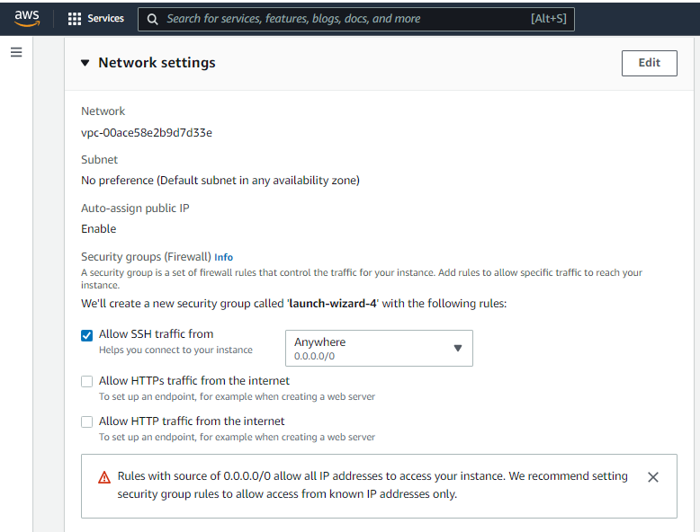

**Step 9) Configure Storage**

In this step we do following things,

* In the Add Storage step, you’ll see that the instance has been automatically provisioned a General Purpose SSD root volume of 8GB. ( Maximum volume size we can give to a General Purpose volume is 16GB)
* You can change your volume size, add new volumes, change the volume type, etc.
* AWS provides 3 types of EBS volumes- Magnetic, General Purpose SSD, Provisioned IOPs. You can choose a volume type based on your application’s IOPs needs.

**Step 10) Advance Details**

Fill Advance details if you want as it is or you can change accordingly your need.

* You can see the launch status meanwhile.

* You can also see the launch log.
* Successfully launched instances
* Click on view all instances

Click on the ‘Instances’ option on the left pane where you can see the status of the instance as ‘Pending’ or ‘ Running’ for a brief while.

* Once your instance is up and running, you can see its status as ‘Running’ now.
* Note that the instance has received a Private IP from the pool of AWS.

**Step 11) Create a EIP and connect to your instance**

An EIP is a static public IP provided by AWS. It stands for Elastic IP. Normally when you create an instance, it will receive a public IP from the AWS’s pool automatically. If you stop/reboot your instance, this public IP will change- it’dynamic. In order for your application to have a static IP from where you can connect via public networks, you can use an EIP.

On the left pane of EC2 Dashboard, you can go to ‘Elastic IPs’ as shown below

Allocate a new Elastic IP Address.

Allocate this IP to be used in a VPC scope.

Your request will succeed if you don’t have 5 or more than 5 EIPs already in your account

**Step 12) Now assign this IP to your instance.**

1. Select the said IP
2. Click on Actions **->** Associate Address

In the next page,

1. Search for your instance and
2. Associate the IP to it.

Click on Associate

Come back to your instances screen, you’ll see that your instance has received your EIP.

**Step 13)**Now open putty from your programs list and add your same EIP in there as below.

**Step 14)**In this step,

Add your private key in putty for secure connection

*If you downloaded .pem then we need to convert file to ppk file using PuttyGen.

1. Go to Auth
2. Add your private key in .ppk (putty private key) format. You will need to convert pem file from AWS to ppk using puttygen

Once done click on “Open” button

* Once you connect, you will successfully see the[Linux](https://www.guru99.com/unix-linux-tutorial.html)prompt.
* Please note that the machine you are connecting from should be enabled on the instance Security Group for SSH (like in the steps above).

Once you become familiar with the above steps for launching the instance, it becomes a matter of 2 minutes to launch the same!

You can now use your on-demand EC2 server for your applications.

Print your name using the instance local machine using python .

**Step 15)**

* Go to the root user by running – “ sudo su “ command and
* Update all libraries present in AMI . – sudo yum update. Or apt-get update
* Install Apache web server = yum install -y httpd.x86_64 or apt-get install -y apache2

**Allow Apache Full on UFW**

In this step, you need to allow Apache Full on UFW will open port 80 and 443 for network traffic, while providing maximum security to the server. So, use the below given UFW command to allow Apache Full through the following command: **Amazon Linux instance commands**

* sudo ufw allow 'Apache Full'
* start server = systemctl start httpd.service
* systemctl enable httpd.service

**Step 16)**

Finally, open your browser and type your AWS ec2 instance IP address. And, it will be looks like the Apache 2 page in the following picture:

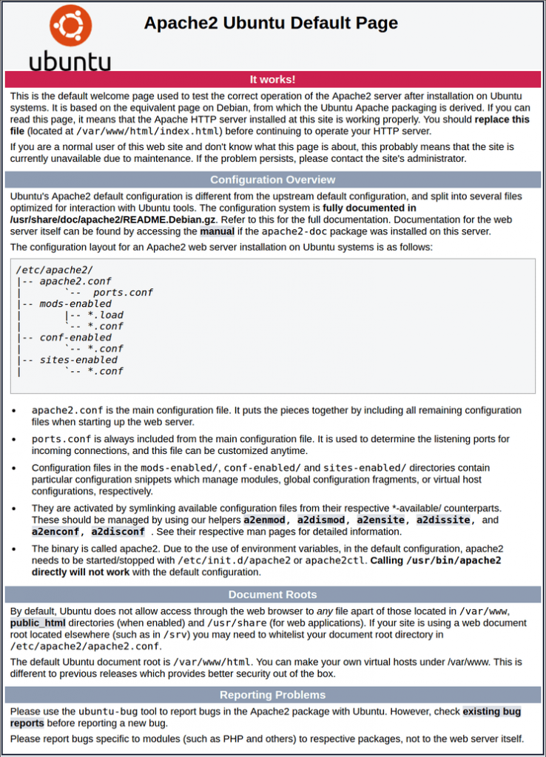

The End